Csc3150 grade

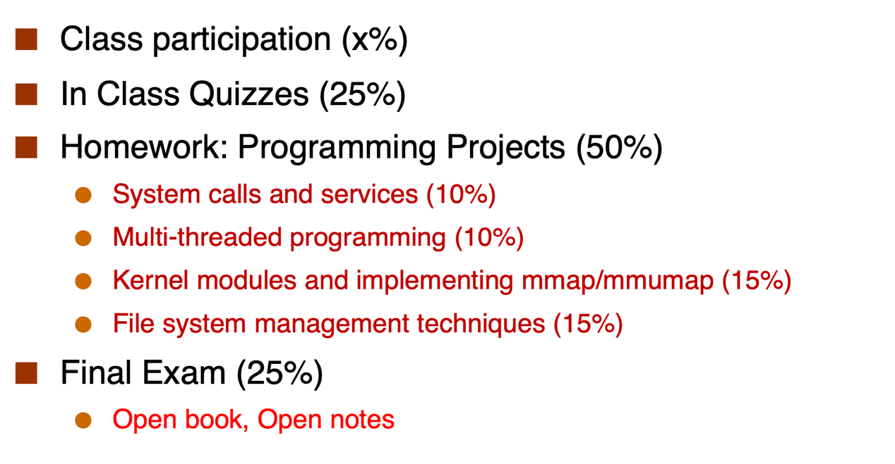

Quiz1: 74/100. Quiz2: 78/100 online quiz:5/7. Quiz:18.96

Final: 81. Final:20.25

Assignment1:60/100. 6

A2:101/100. 10.1

A3:111/100. 16.65

A4:100/100. 15

86.9